Spring REST using Spring Boot 3 Assignments
Create a Spring Web Project using Maven
Objective
The objective of this assignment is to create a basic Spring Web project using Maven and understand the structure and configuration of a Spring Boot application.
1. Project Creation Using Spring Initializr
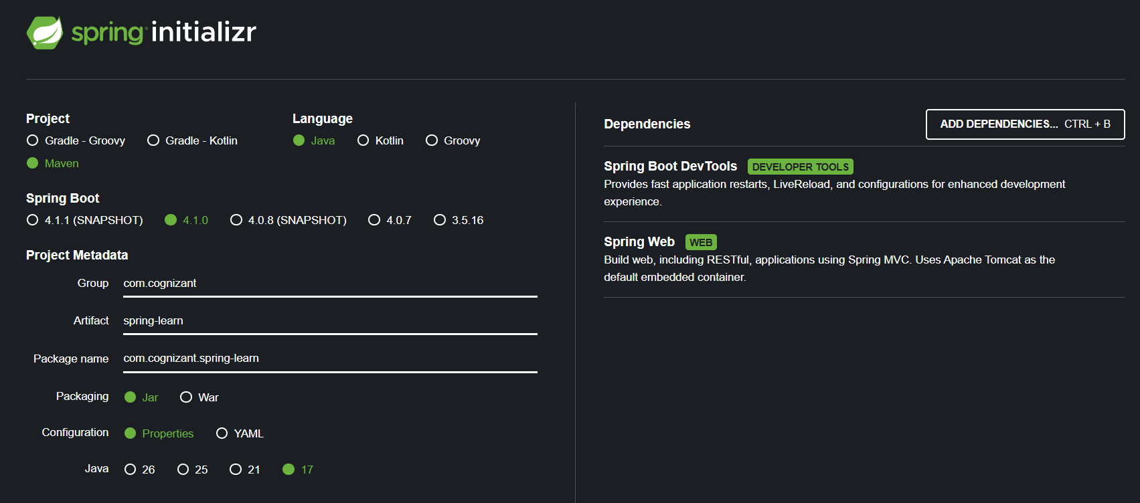
2. Build the Project
The project can be built using the Maven command specified in the assignment:
mvn clean package -Dhttp.proxyHost=proxy.cognizant.com -Dhttp.proxyPort=6050 -Dhttps.proxyHost=proxy.cognizant.com -Dhttps.proxyPort=6050 -Dhttp.proxyUser=123456
3. SpringLearnApplication.java
package com.cognizant.springlearn;

import org.slf4j.Logger;
import org.slf4j.LoggerFactory;
import org.springframework.boot.SpringApplication;
import org.springframework.boot.autoconfigure.SpringBootApplication;

@SpringBootApplication
public class SpringLearnApplication {

private static final Logger LOGGER =
LoggerFactory.getLogger(SpringLearnApplication.class);

public static void main(String[] args) {
SpringApplication.run(SpringLearnApplication.class, args);
LOGGER.info("Inside main");
}
}
4.pom.xml
<dependency>
<groupId>org.springframework.boot</groupId>
<artifactId>spring-boot-starter-web</artifactId>
</dependency>

<dependency>
<groupId>org.springframework.boot</groupId>
<artifactId>spring-boot-devtools</artifactId>
<scope>runtime</scope>
<optional>true</optional>
</dependency>

<dependency>
<groupId>org.springframework.boot</groupId>
<artifactId>spring-boot-starter-test</artifactId>
<scope>test</scope>
</dependency>

